
Company
Logotype

Cone Beam Computed Tomography- Report



Porur Dental X-rays & CBCT

Patient Name : Mrs. Nandhini | Date of Report : 20.07.2024
Age/ Gender : 32 years/ Female | Region of Interest : CBCT Sectional Mandible
Referring doctor: S V Dental Care | Indication : Implant assessment
Clinical Notes: Nil
PATIENT INFORMATION

CBCT- Sectional Mandible provided
CBCT – IMAGE DETAILS

RADIOGRAPHIC INTERPRETATION

- Complete loss of crown and root structure in relation to 37.
- Presence of hyperdense restorative material within the pulp canal of 37 extending upto the apical third of the root is evident. In addition, resorptive changes present along the apical third of the distal root, presence of a diffuse periapical hypodensity measuring 8.08 x 3.19 x 4.24 mm in dimension with irregular borders is evident.

IMPLANT ASSESSMENT

 | 36 region | 37 region
Sub-Crestal (in mm) | 10.26 | 8.49
Width along the middle third of alveolar ridge  (in mm) | 8 | 9.29
Distance between alveolar ridge and the inferior alveolar nerve canal (in mm) | 10.11 | 9.15
Distance between alveolar ridge and the inferior border of mandible (in mm) | 17.63 | 16.15

RADIOGRAPHIC IMPRESSION

- Root canal treated with periapical pathology: 37

Kindly correlate with clinical findings


IMAGES FOR REFERENCE

RECONSTRUCTED PANORAMIC VIEW

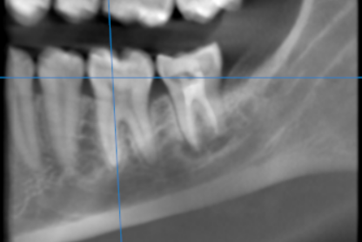

3-DIMENSIONAL VIEW

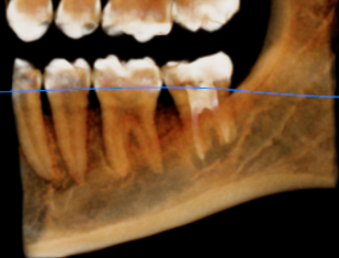

CROSS SECTIONAL VIEW

36 region | 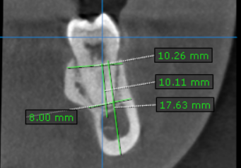
37 region | 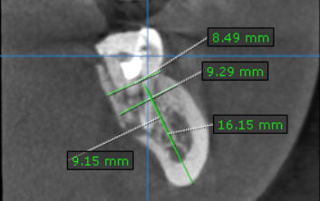

**** End of report ****

